How to Capture and Export UPC Data
This guide walks through capturing UPC and serial number pairs for firearms using the UPC Capture tool in the Orchid portal, and exporting that data to Excel.
Steps
Open UPC Capture. In the Orchid portal (eBound), open the left sidebar menu. Under FFL tools select UPC Capture. You will land on the UPC Capture page showing your list of existing instances and a New Instance button.
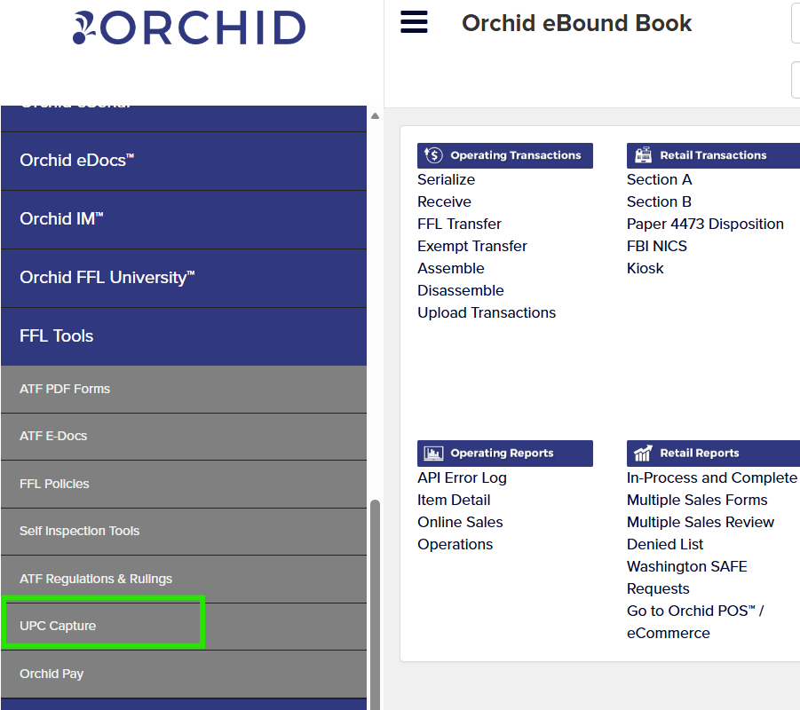
- Click New Instance.
- Give it a name (for example "UPC Capture 2026") and select the date.
- Click Save. You will be taken to the UPC Capture Data Entry screen, ready for scanning.
- Enter the UPC number (12 or 13 digits) in the UPC field.
- Enter the firearm's serial number in the Serial Number field.
- Click Add. The record appears in the table below under Scan Number, UPC, and Serial Number, with each entry numbered in order as you add it, and the running total updates each time (for example "Total: 1"). Repeat this for every firearm you are capturing.
Export the data. When you are done scanning, click Export in the upper right toolbar. This downloads|
